**Team14 Project Specification**

**Product Owner: Junlin Wang**

**AndewID: junlin2**

* **Product Backlog**

1. Basic Functionalities:
   1. Log in/out, register, email authentication,
   2. Follow/unfollow other users
   3. Reset password
   4. Share website using social medias like Twitter, Facebook, Weibo, etc.
2. Posts searching system:
   1. Users could search posts according to the basic information of posts like gender, brand, height and post location.
   2. Users could also enter keywords of tags to find relevant posts.
3. Post system:
   1. When making a new post, user need to specify basic information like gender, season, items included in the post.
   2. Users could add tag information to the post, navigate to details of a photo (with tags)
   3. Redirect to shopping page: when creating a post, users can choose to include the URL of clothes in that photo. In that case, other users can click the corresponding tag to redirect to the shopping site.
4. Profile system
   1. Users could update their profile photos and bio under “My profile” tab
   2. Users could check their liked post collection under “My favorites” tab
   3. Users could manage their history posts under “My posts” tab
5. Online chat system

Support private online messaging between users

1. Posts display

The home page posts using suggest algorithm considering both post time and popularity of the post(likes).

* **Sprint Backlog**

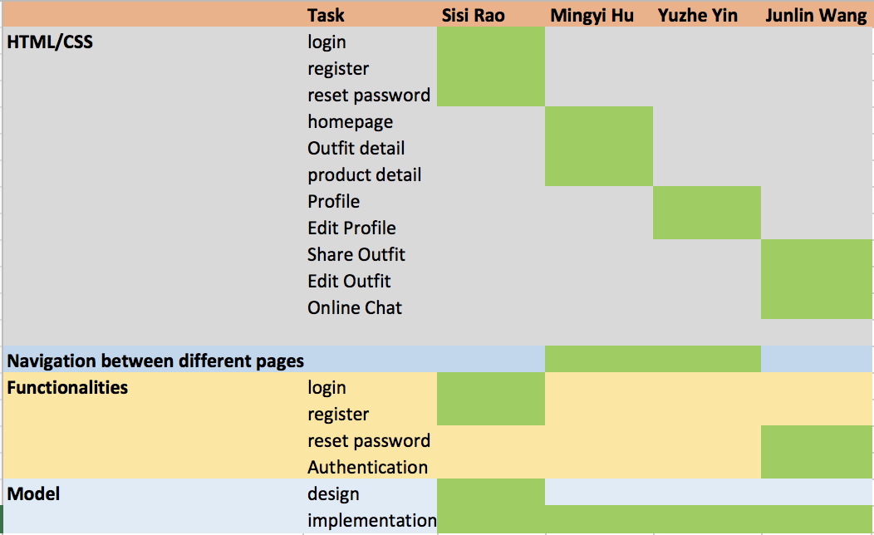

* **Data Models**

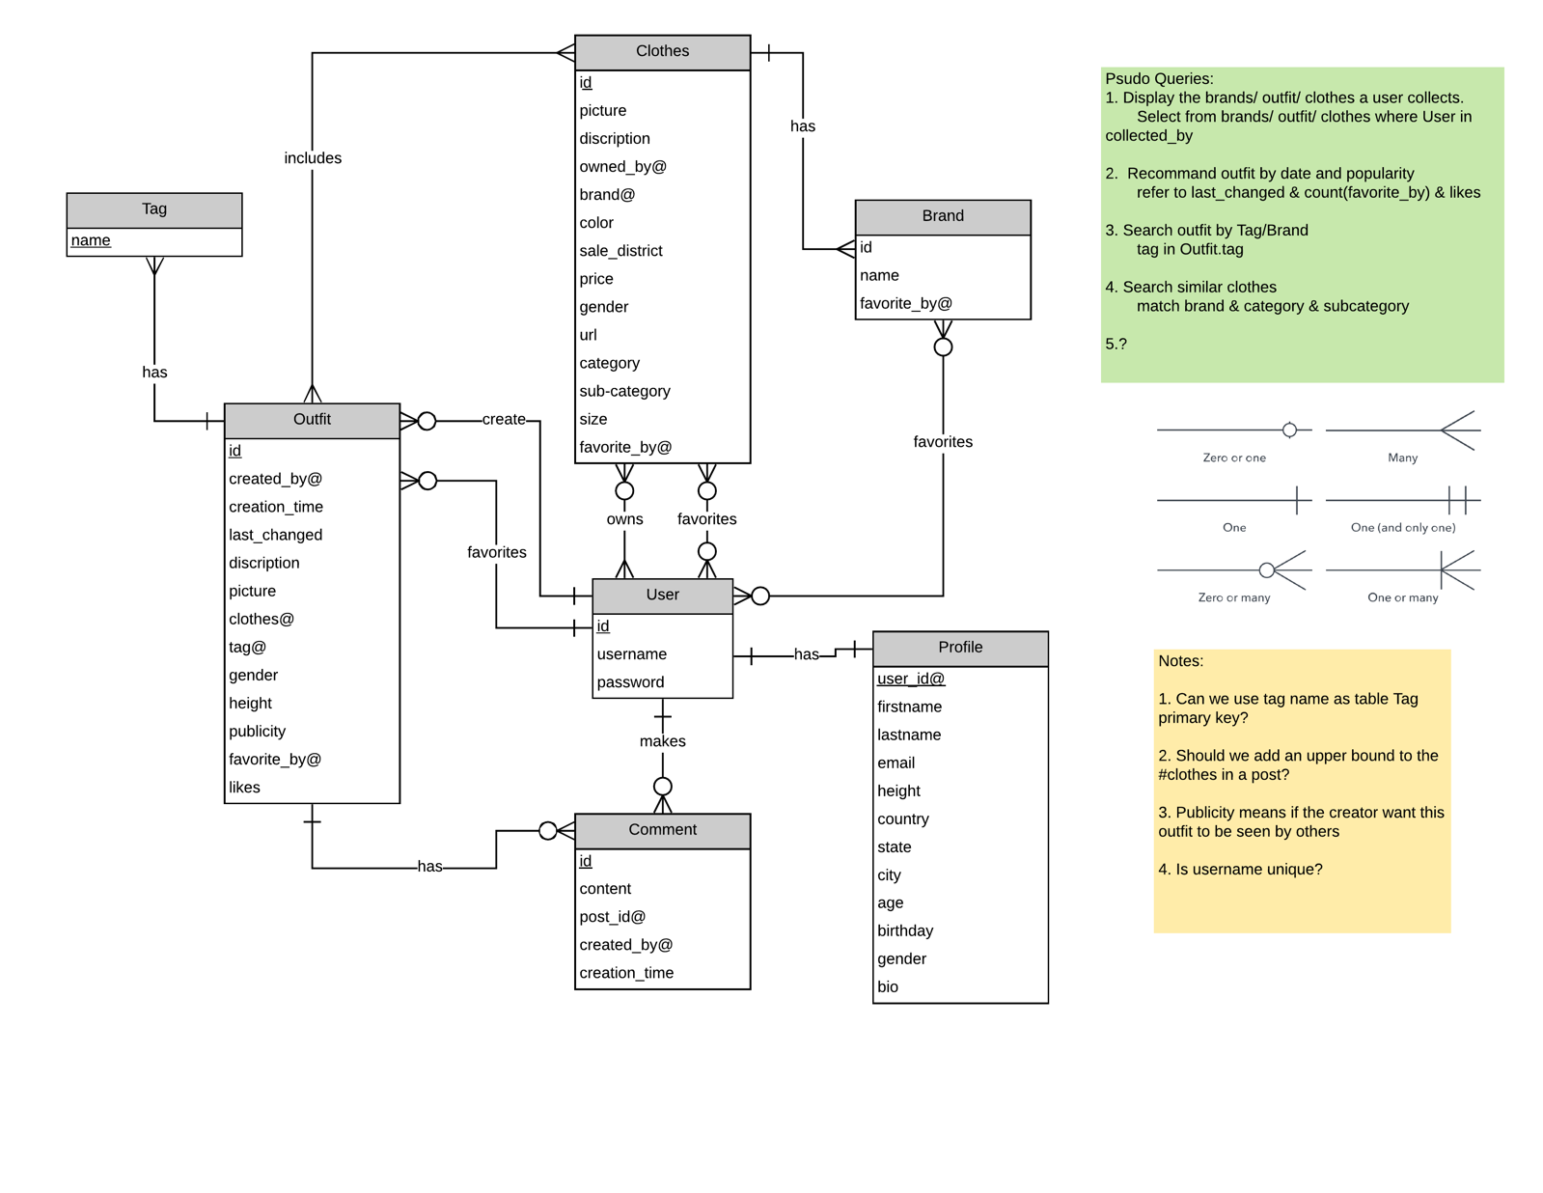

* **Mock-Up HTML**

After user login the website, the homepage will display as following. User can view all the posts of other users and use filter function to filter the posts

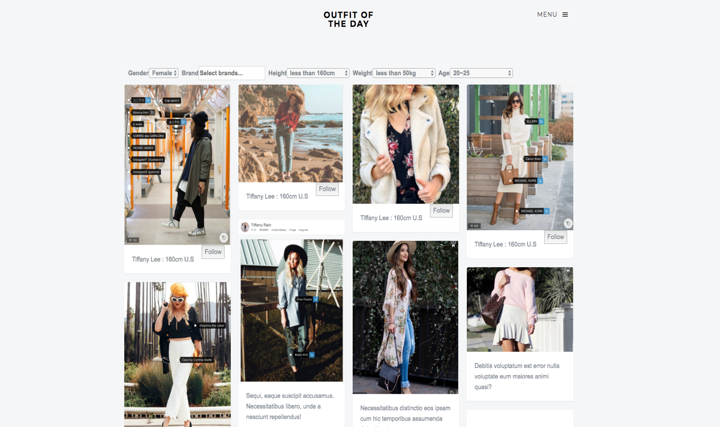

The menu bad can navigate user to his/her own page, share outfit pages, contact us pages.

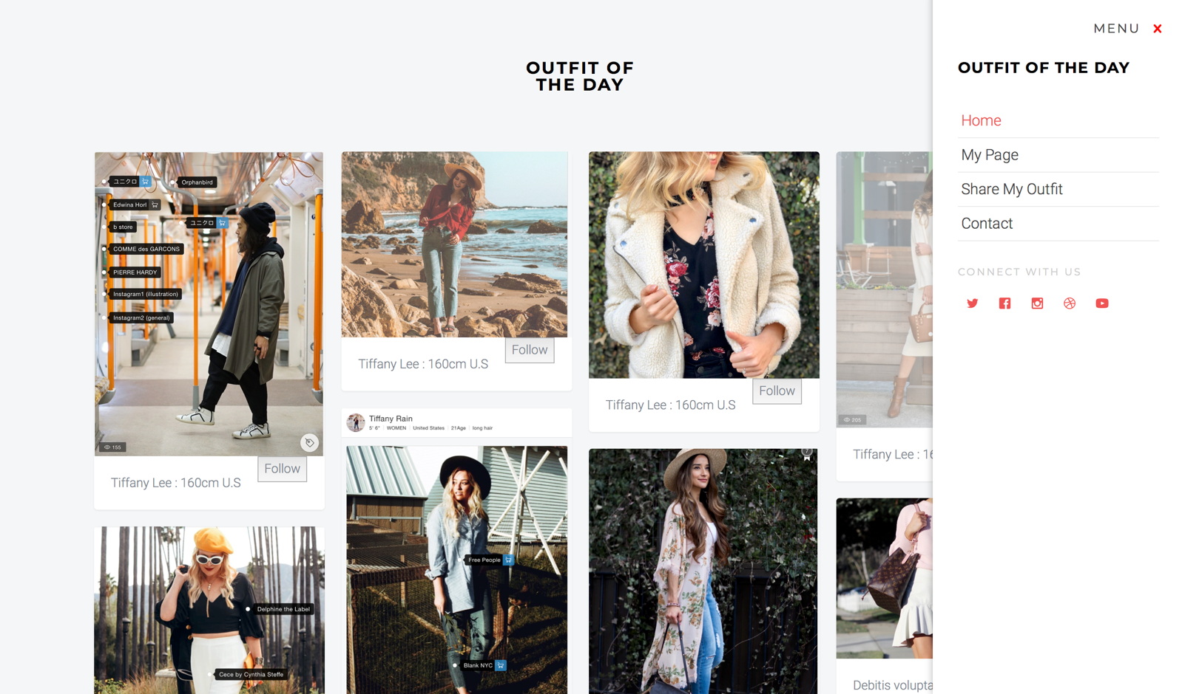

When user click a post (photo) to see its detail, the post pops up and there is a show tag button to display all the tags related to the products in the post. The tag with a “cart” sign means that user can click this tag and navigate to the product detail page.

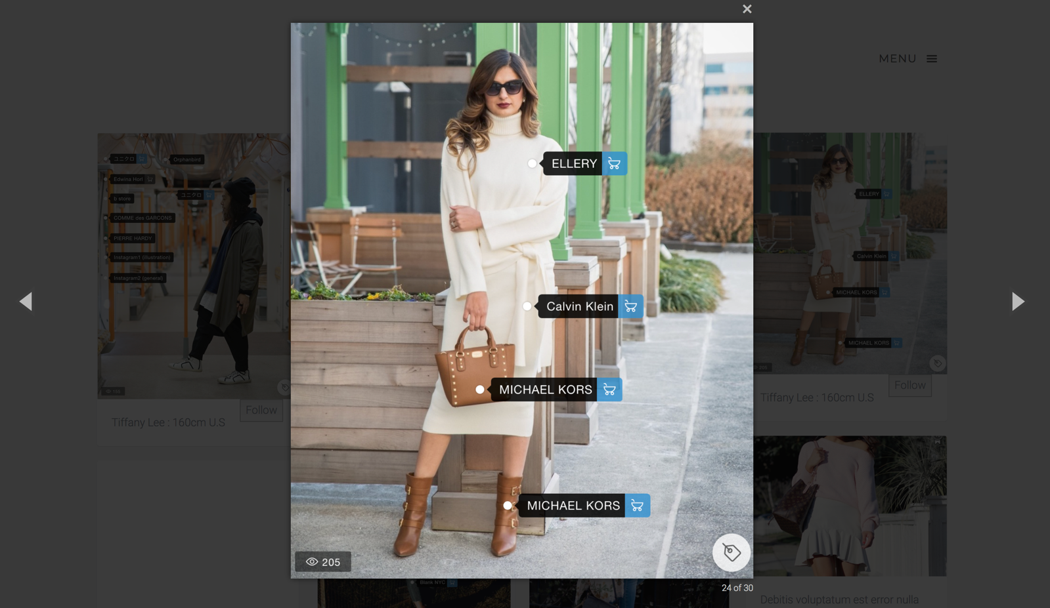

Product detail page. This page should contain the brand, description and price of a specific product and a link to navigate to online store to buy it.

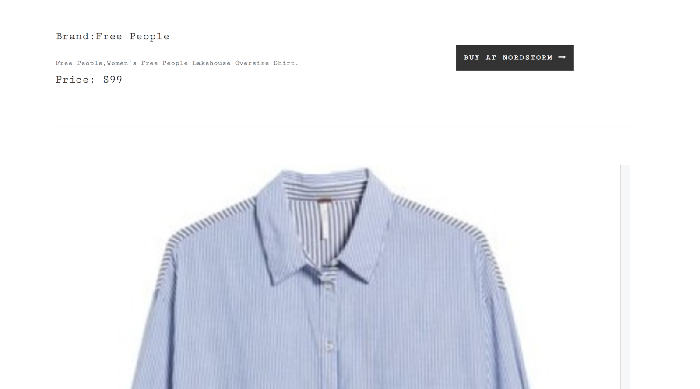

Profile page contains tabs of profile, history posts and favorites collection.

Users could update the profile bio and photos here

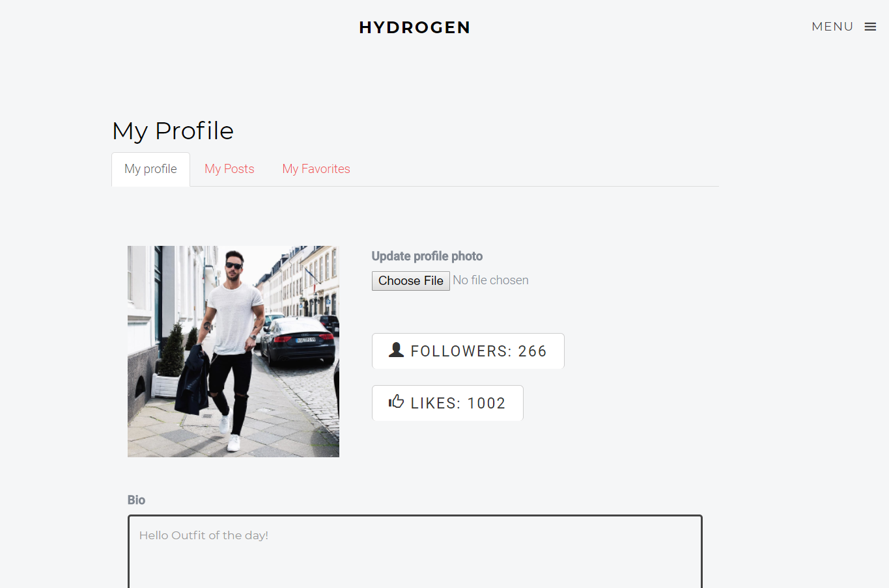

When adding a new post, users could specify the main categories of the post, add description paragraph, and add specific search tags.

